Quick Sort and Merge Sort

Done By: Rohit Karunakaran Roll No: 58

Aim: Implement Quick sort and Merge Sort

Data Structures used: Array

Algorithm for Quick Sort (Quicksort)

Input: The array to be sorted and the index of the first and the last element
Output : The sorted Array
Data Structure : Array

Steps
  - Step 1: Start
  - Step 2: if(first<last) then
  - Step 1: q = Partition(arr,first, last)
  - Step 2: Quicksort(arr,first,q-1)
  - Step 3: Quicksort(arr,q+1,last)
  - Step 3: endif
  - Step 4: Stop

Algorithm for Partition (Partition)

Input: The array to be partitioned and the first and the last node(also known as the pivot)
Output: The correct index of the pivot in the sorted array
Data Structure used: Array

Steps
- Step 1: Start
- Step 2: pivot = arr[last]
- Step 3: i = first-1
- Step 4: j = first
- Step 5: while j<=last-1 then
- Step 1: if arr[j] <= pivot then
- Step 1: i=i+1
- Step 2: swap arr[i] and arr[j]
- Step 2: EndIf
- Step 6: End While
- Step 7: swap arr[i+1] and arr[last]
- return i+1

Algorithm for Merge Sort (merge_sort)
Input: The array and the starting and the ending index of the array to be sorted
Output : The sorted array
Data Structure used: Array

Steps
- Step 1: Start
- Step 2: if(first<last) then
- Step 1: (first+last)/2
- Step 2: merge_sort(arr,first,mid)
- Step 3: merge_sort(arr,mid+1,last)
- Step 4: merge(arr,first,mid,last)
- Step 3: Endif
- Step 4: Stop

Algorithm for Merge (merge)

Input: The array and upperbound and the lower bound and the middle element in the array
Output : The array is sorted
Data Structure used: Binary trees

Steps
- Step 1: Start
- Step 2: n1 = middle-lower+1
- Step 3: n2 = upper – middle
- Step4: let L[1...n1+1] and R[1….n2+1]
- Step 5: for i=1 to n1 do
- Step 1: L[i] = arr[lower+i-1]
- Step 6: Done
- Step 7: for j = 1 to n2 do
- Step 1: R[j] = arr[middle+j]
- Step 8: done
- Step9: L[n1+1] = ∞
- Step 10: R[n2+1]= ∞
- Step 11: i=1
- Step 12: j=1
- Step 13: for k=first to last
- Step1: if L[i]<=R[j] then
- Step 1: A[k] = L[i]
- Step 2: i++
- Step 2: else
- Step 1: A[k] = R[j]
- Step 2: j++
- Step 3: endif
- Step 14: Done
- Step 15 :Stop

Program Code

#include<stdio.h>
#include<stdlib.h>
#include<string.h>
#include<time.h>

#define MAX_SIZE 100

typedef struct student_structure{
char name[101];
float height;
float weight;
}student;

enum prop{NAME,HEIGHT,WEIGHT};
char prop_name[][10]={"Name","Height","Weight"};

/********************************
* Quick Sort
* *****************************/
int partition(student *list, int first, int pivot, enum prop a){
int i,j;

i = first;
j = first-1;
while(i<pivot){
int flag = 0;

switch(a){
case NAME:
if(strcmp(list[i].name,list[pivot].name)<=0) flag = 1;
break;
case HEIGHT:
if(list[i].height<=list[pivot].height) flag = 1;
break;
case WEIGHT:
if(list[i].weight<=list[pivot].weight) flag = 1;
break;
}
if(flag){
j++;
student temp = list[i];
list[i] = list[j];
list[j] = temp;
}
i++;
}
j++;
if(pivot != j){
student temp = list[pivot];
list[pivot] = list[j];
list[j] = temp;
}
return j;
}

void quick_sort(student *list,int first,int last,enum prop a){
if(first<last){
int q = partition(list, first,last,a);
quick_sort(list, first, q-1,a);
quick_sort(list,q+1,last,a);
}
}

/********************************
* Merge Sort
* ******************************/
void merge(student *list,int first,int mid,int last,enum prop a){
int n = last-first+1;
student *temp =(student*)malloc(n*sizeof(student)) ;

int i,j,flag,k=0;
for(i=first,j=mid+1;i<=mid&&j<=last;)
{
flag = 0;
switch(a){
case NAME:
if(strcmp(list[i].name,list[j].name)<0){
flag = 1;
}
break;
case HEIGHT:
if(list[i].height<=list[j].height){
flag =1;
}
break;
case WEIGHT:
if(list[i].weight<=list[j].weight){
flag =1;
}
break;
}
if(flag){ //if the flag is true then add i, else add j;
strcpy(temp[k].name,list[i].name);
temp[k].height= list[i].height;
temp[k].weight = list[i].weight;
i++;
}
else{
strcpy(temp[k].name,list[j].name);
temp[k].height= list[j].height;
temp[k].weight = list[j].weight;
j++;
}
k++;
}
while(i<=mid){
temp[k] = list[i];
i++;k++;
}
while(j<=last){
temp[k] = list[i];
j++;k++;
}
k=0;
for(i = first;i<=last;i++){
strcpy(list[i].name,temp[k].name);
list[i].height= temp[k].height;
list[i].weight = temp[k].weight;
k++;
}
}

void merge_sort(student *list, int first, int last, enum prop a)
{
if(first<last){
int mid = (first+last)/2;
merge_sort(list,first,mid,a);
merge_sort(list,mid+1,last,a);
merge(list,first,mid,last,a);
}
}

void list_copy (student* l1, student* l2,int n){
for(int i=0;i<n;i++){
strcpy(l1[i].name,l2[i].name);
l1[i].height = l2[i].height;
l1[i].weight = l2[i].weight;
}
}

int main(){

student *student_list = (student*) malloc(MAX_SIZE*sizeof(student));
student *temp_list = (student*) malloc(MAX_SIZE*sizeof(student));
// FILE *file = fopen("./output.txt","w");

char first_name[50];
char last_name[50];
int n = 0;
int i;
enum prop a = HEIGHT;

clock_t t;
double time_taken;

if(freopen("./student_data.txt","r",stdin)){
FILE *quickSortOp = fopen("./quicksortop.txt","w");
FILE *mergeSortOp = fopen("./mergesortop.txt","w");
while(scanf("%s %s %f %f\n", first_name,last_name,&(student_list[n].height),
&(student_list[n].weight))==4) {
//conactinate the first and the last names
strcat(student_list[n].name, first_name);
strcat(student_list[n].name, " ");
strcat(student_list[n].name, last_name);
n++;
}
fprintf(quickSortOp,"QUICK SORT\n");
fprintf(quickSortOp,"============\n");

// for(int a=NAME;a<=WEIGHT;a++ ){ //For iterating through all the
list_copy(temp_list,student_list,n);

t = clock();
quick_sort(temp_list,0,n-1,a);
t = clock()-t;

i=0;
fprintf(quickSortOp,"Sorted according to order of the %s\n\n",prop_name[a]);
while(i<n){
fprintf(quickSortOp,"%s %.2f %.2f\n",temp_list[i].name,temp_list[i].height,temp_list[i].weight);
i++;
}

time_taken = ((double)t)/(CLOCKS_PER_SEC);
fprintf(quickSortOp,"Time taken = %lf seconds",time_taken);
fprintf(quickSortOp,"\n\n");
// }

fprintf(mergeSortOp,"MERGE SORT\n");
fprintf(mergeSortOp,"============\n");

// for(int a = NAME; a<=WEIGHT;a++){
list_copy(temp_list,student_list,n);

t = clock();
merge_sort(temp_list,0,n-1,a);
t = clock()-t;

i=0;
fprintf(mergeSortOp,"Sorted according to order of the %s\n\n",prop_name[a]);
while(i<n){
fprintf(mergeSortOp,"%s %.2f %.2f\n",temp_list[i].name,temp_list[i].height,temp_list[i].weight);
i++;
}

time_taken = ((double)t)/(CLOCKS_PER_SEC);
fprintf(mergeSortOp,"Time taken = %lf seconds",time_taken);
fprintf(mergeSortOp,"\n\n");
// }
}

return 0;
}

Result: The program compiled successfully and required output was obtained
Sample input and output

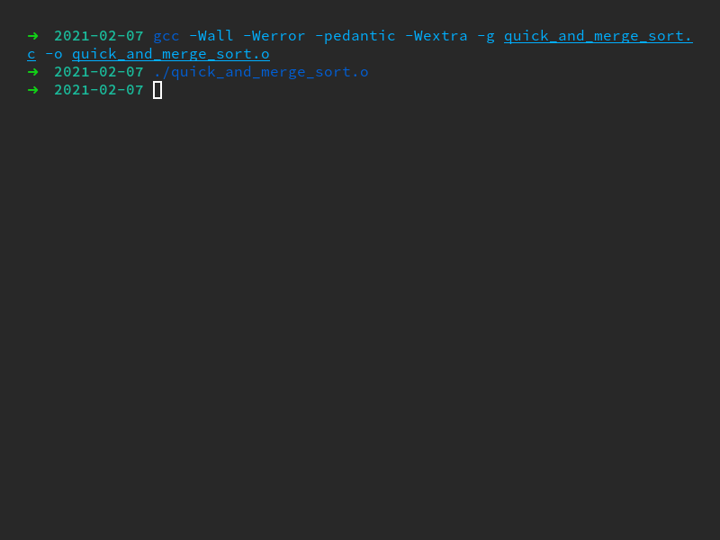
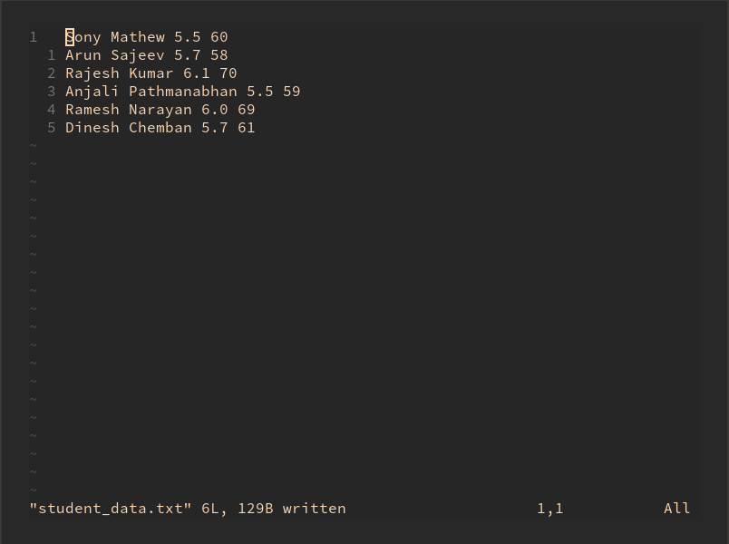

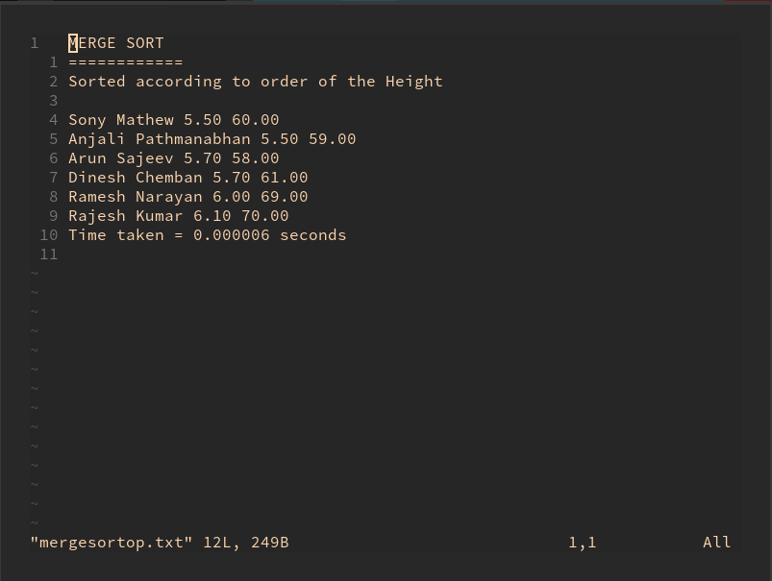
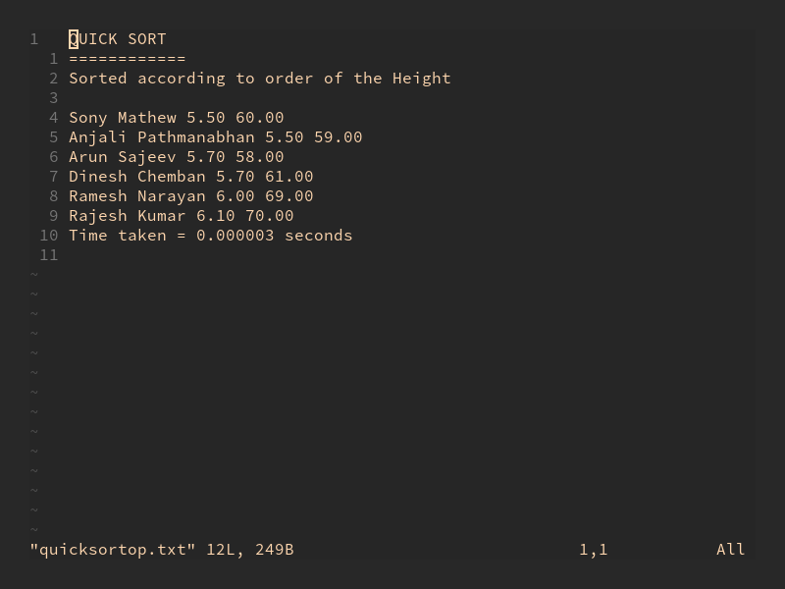

Heap Sort

Done By: Rohit Karunakaran Roll No: 58

Aim: Sort an array of numbers using heap sort

Data Structures used: Array

Algorithm for Create Heap (create_heap)

Input: The array to be sorted and size of the array
Output : The elements of the array now follows the heap property
Data Structure : Array

Steps

- Step 1: Start
- Step 2: i = 1
- Step 3: while i<=n do
- Step 3: j = i
- Step 4: while j>1 do
- Step 1: if A[j] > A[j/2] then
- Step 1: swap (A[j],A[j/2])
- Step 2: j=j/2
- Step 2: else
- Step 1: j = 1
- Step 3: endif
- Step 5: EndWhile
- Step 6: i = i+1
- Step 4: endWhile
- Step 5: Stop

Algorithm for Remove max (remove_max)

Input: The largest element in the heap and the index
Output: The largest and the element at the bottom of the heap
Data Structure used: Array

Steps
- Step 1: Start
- Step 2: temp = A[i]
- Step 3: A[i] = A[1]
- Step 4: A[1] = temp
- Step 5: Stop

Algorithm for Rebuild Heap (rebuild_heap)
Input: The Array after the remove_max algorithm
Output: The array satisfies the heap property
Data Structure used: Array

Steps
- Step 1: Start
- Step 2: if(i == 1)then
- Step 1: retun
- Step 3: else
- Step 1: j = 0
- Step 2: flag = true
- Step 3: while(flage == true) do
- Step 1: leftchild = j*2
- Step 2: rightchild = j*2+1
- Step 3: largest = j
- Step 4: if(leftchild<=i and A[largest]<A[leftchild]) then
- Step 1: largest = leftchild
- Step 5: endIf
- Step 6: if(rightchild<=i and A[largest]<A[rightchild]) then
- Step 1: largest = rightchild
- Step 7: endIf
- Step 8: if(largest!=j) then
- swap(A[j], A[largest])
- Step 9: else
- Step 1: flag = flase
- Step 10: endif
- Step 4: endWhile
- Step 4: Endif
- Step 5: Stop

Program Code

#include<stdio.h>
#include<stdlib.h>

void swap(int* arr, int i, int j){
int temp = arr[i];
arr[i] = arr[j];
arr[j] = temp;
}

void create_heap(int *arr, int n){
int i = 0;
int k,j;
while(i<n){
j = i;
while(j>0){
k = j%2==0?j/2-1:j/2;
if(arr[j]>arr[k]){
swap(arr,j,k);
j = k;
}
else{
j=0;
}
}
i++;
}
}

void heapify(int *arr, int i){
//i is the upper bound
if(i == 0){
return; //the array is sorted
}
else{
int j=0;
int flag = 1;
while(flag){
int largest = j;//initially assume the parent is the largerst which in the first loop is'nt
int lc = 2*j+1;
int rc = 2*(j+1);

if(lc<=i && arr[lc]>arr[largest])largest = lc;
if(rc<=i && arr[rc]>arr[largest])largest = rc;

if(j!=largest){
swap(arr,j,largest);
}
else{
// printf("swapped\n");
flag =0; //if there is no change in the largest element then the array is heapified
}
}

}
}

void heap_sort(int *arr, int n){
create_heap(arr,n);
for(int i = n-1;i>=0;i--){
swap(arr,i,0);
heapify(arr,i-1);
}
}

int main(){
int n;
int* arr = (int*)malloc(20*sizeof(int));

printf("Enter the number of elements: ");
scanf("%d",&n);

printf("Enter the elements : ");
for(int i = 0; i<n;i++){
scanf("%d",arr+i);
}

heap_sort(arr,n);

for(int i = 0;i<n;i++){
printf("%d ",arr[i]);
}
printf("\n");

return 0;
}

Result:
The program was compiled successfully and the required output was obtained

